**DELPHİ XE10.1 ANDROID AND HC-05 BLUETOOTH ARDUINO CONTROL PROJECT**

Our project has been developed using Fire Monkey structure in Arduino Ide and Delphi XE10.1 environments. Its main purpose is to control the Arduino Uno Board with Android devices over the HC-05 Bluetooth module. Additionally, RGB Led, Neopixel Led and 0.96 inch TFT screen were used for visualization and tests.

Here, apart from the basic elements of the circuit, even if you do not use neopixel led and oled tft screen, you can run your circuit by removing the necessary code blocks from the Arduino Ino file.

**Important**: At the time of uploading the Arduino code, you need to remove the RX and TX pins on the Arduino or HC-05, and re-plug it after the installation is completed. Otherwise, you will not be able to upload the code.

**Proje Component List**

* Arduino Uno
* Bredboard
* Hc-05 Bluetooth
* Common Catode RGB Led
* WS2812 Neopixel Led
* 128*64 Oled TFT SSD1306 (JMD 0.96A-1)
* 3x 1K Resistor

**Fritzing Picture**

(Fritzing File available in Project folder.)

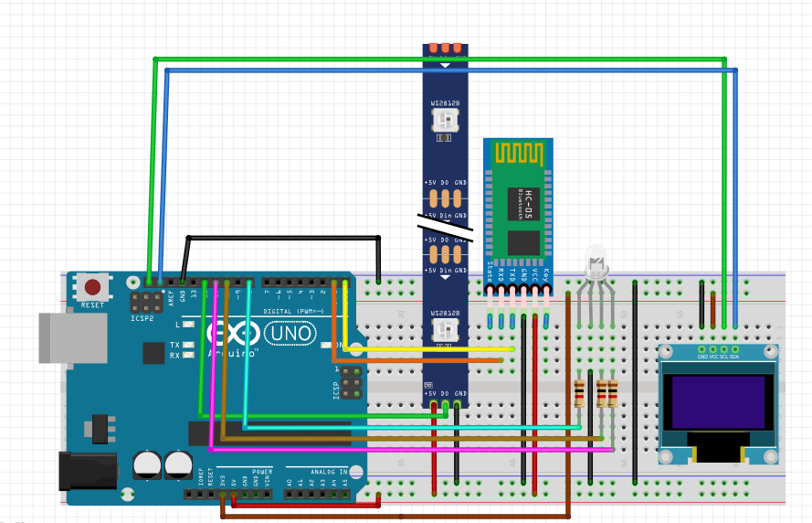

**Circuit Assembly Picture**

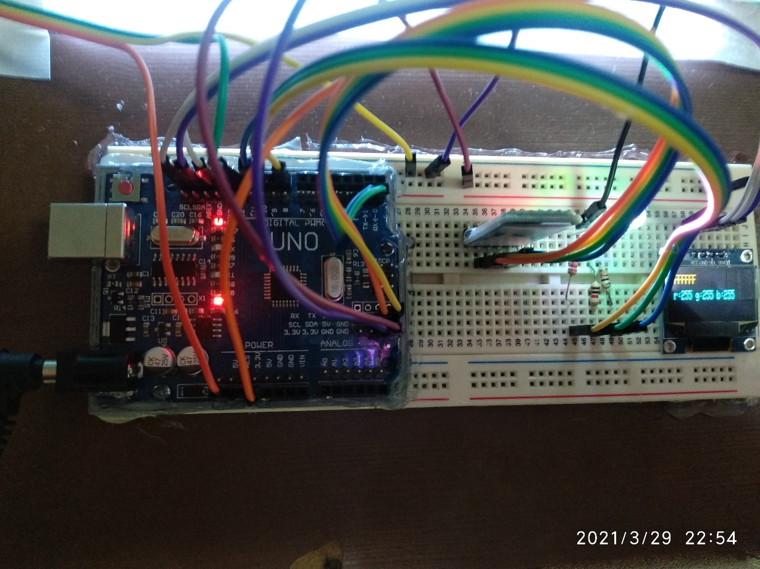

Don't think of this circuit as just an RGB color circuit. I would like you to see the Arduino board as an example circuit that we can easily control in all kinds of projects on Android.

I hope I have benefited, if you do well in your other projects.

Best regards…

IF YOU BENEFIT FROM THE PROJECT I HAVE PREPARED OR IF YOU THINK IT WILL PROVIDE BENEFIT FOR YOU, YOU CAN CONTRIBUTE TO THE IBAN NUMBER BELOW WITH 3 $ EFT.

THANKS.

TR73 0006 2001 4480 0006 6798 32